Question Paper
Quiz-2

Max Time : 15 Minutes Max Marks : 05

Q.1 Find all poles of 

(a) 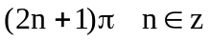 (b) 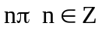 (c) 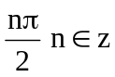 (d) None of these

Q.2 Find the integral 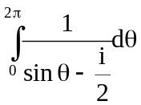
(a) 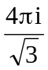 (b) 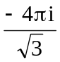 (c) 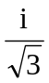 (d) None of these

Q.3 Find the integral o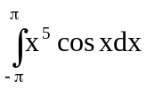
(a) (b) 1 (c) -1 (d) None of these

